RADIO STATIONS
WADK-AM 1540/ WMNP-FM 99.3
ANNUAL EEO PUBLIC FILE REPORT

November 20, 2015

WADK (AM 1540), Newport, Rhode Island
Website: WWW.WADK.COM

WMNP (FM 99.3), Block Island, Rhode Island
Website: WWW.MIXX993.COM

Bonnie Gomes
General Manager

2014 Annual EEO Public File Report
WADK (AM)/WMNP (FM)

The purpose of this EEO Public File Report (“Report”) is to comply with Section 73.2080 (c) (6) of the FCC’s EEO Rule. This Report has been prepared on behalf of the Station Employment Unit that is comprised of the following station(s): WADK(AM), Newport, Rhode Island and WMNP(FM), Block Island, Rhode Island, and is required to be placed in the public inspection files of these stations, and posted on their websites, if they have websites.
The information contained in this Report covers the time period beginning December 1 2014, to and including November 30, 2015 (the “Applicable Period”).
The FCC’s EEO Rule requires that this Report contain the following information:
- A list of all full-time vacancies filled by the Station(s) comprising the Station Employment Unit during the Applicable Period;
- For each such vacancy, the recruitment source(s) utilized to fill the vacancy (including, if applicable, organizations entitled to notification pursuant to Section 73.2080(c)(1)(ii) of the EEO Rule, which should be separately identified), identified by name, address, contact person and telephone number;
- The recruitment source that referred the hiree for each full-time vacancy during the Applicable Period;
- Data reflecting the total number of persons interviewed for full-time vacancies during the Applicable Period and the total number of interviewees referred by each recruitment source utilized in connection with such vacancies; and
- A list and brief description of the initiatives undertaken pursuant to Section 73.2080(c) (2) of the FCC rules.
Appendices 1, 2 and 3 which follow have been designed, in the aggregate, to provide the required information. Please note that the numbers listed on Appendix 2 under the column entitled “Full-time Positions for Which This Source Was Utilized” refer to the number of the full-time job positions listed on Appendix 1.
For purposes of this Report, a vacancy was deemed “filled” not when the offer was extended but when the hiree accepted the job offer.

Appendix 1 to

Annual EEO Public File Report

Covering the Period from December 1, 2014 to November 30, 2015

Station(s) Comprising Station Employment Unit: WADK (AM)/ WMNP (FM)

Section 1: Vacancy Information

No. | Full-time Positions Filled By Job Title | Recruitment Source of Hiree
1 | Account Executive (sales position) | South County Chamber Job Bank

Total Number of Persons Interviewed During Applicable Period: 15

Appendix 2 to
Annual EEO Public File Report Covering the Period from
December 1, 2014 to November 30, 2015
Station(s) Comprising Station Employment Unit: WADK (AM)/WMNP (FM)

Section 2: Recruitment Source Information
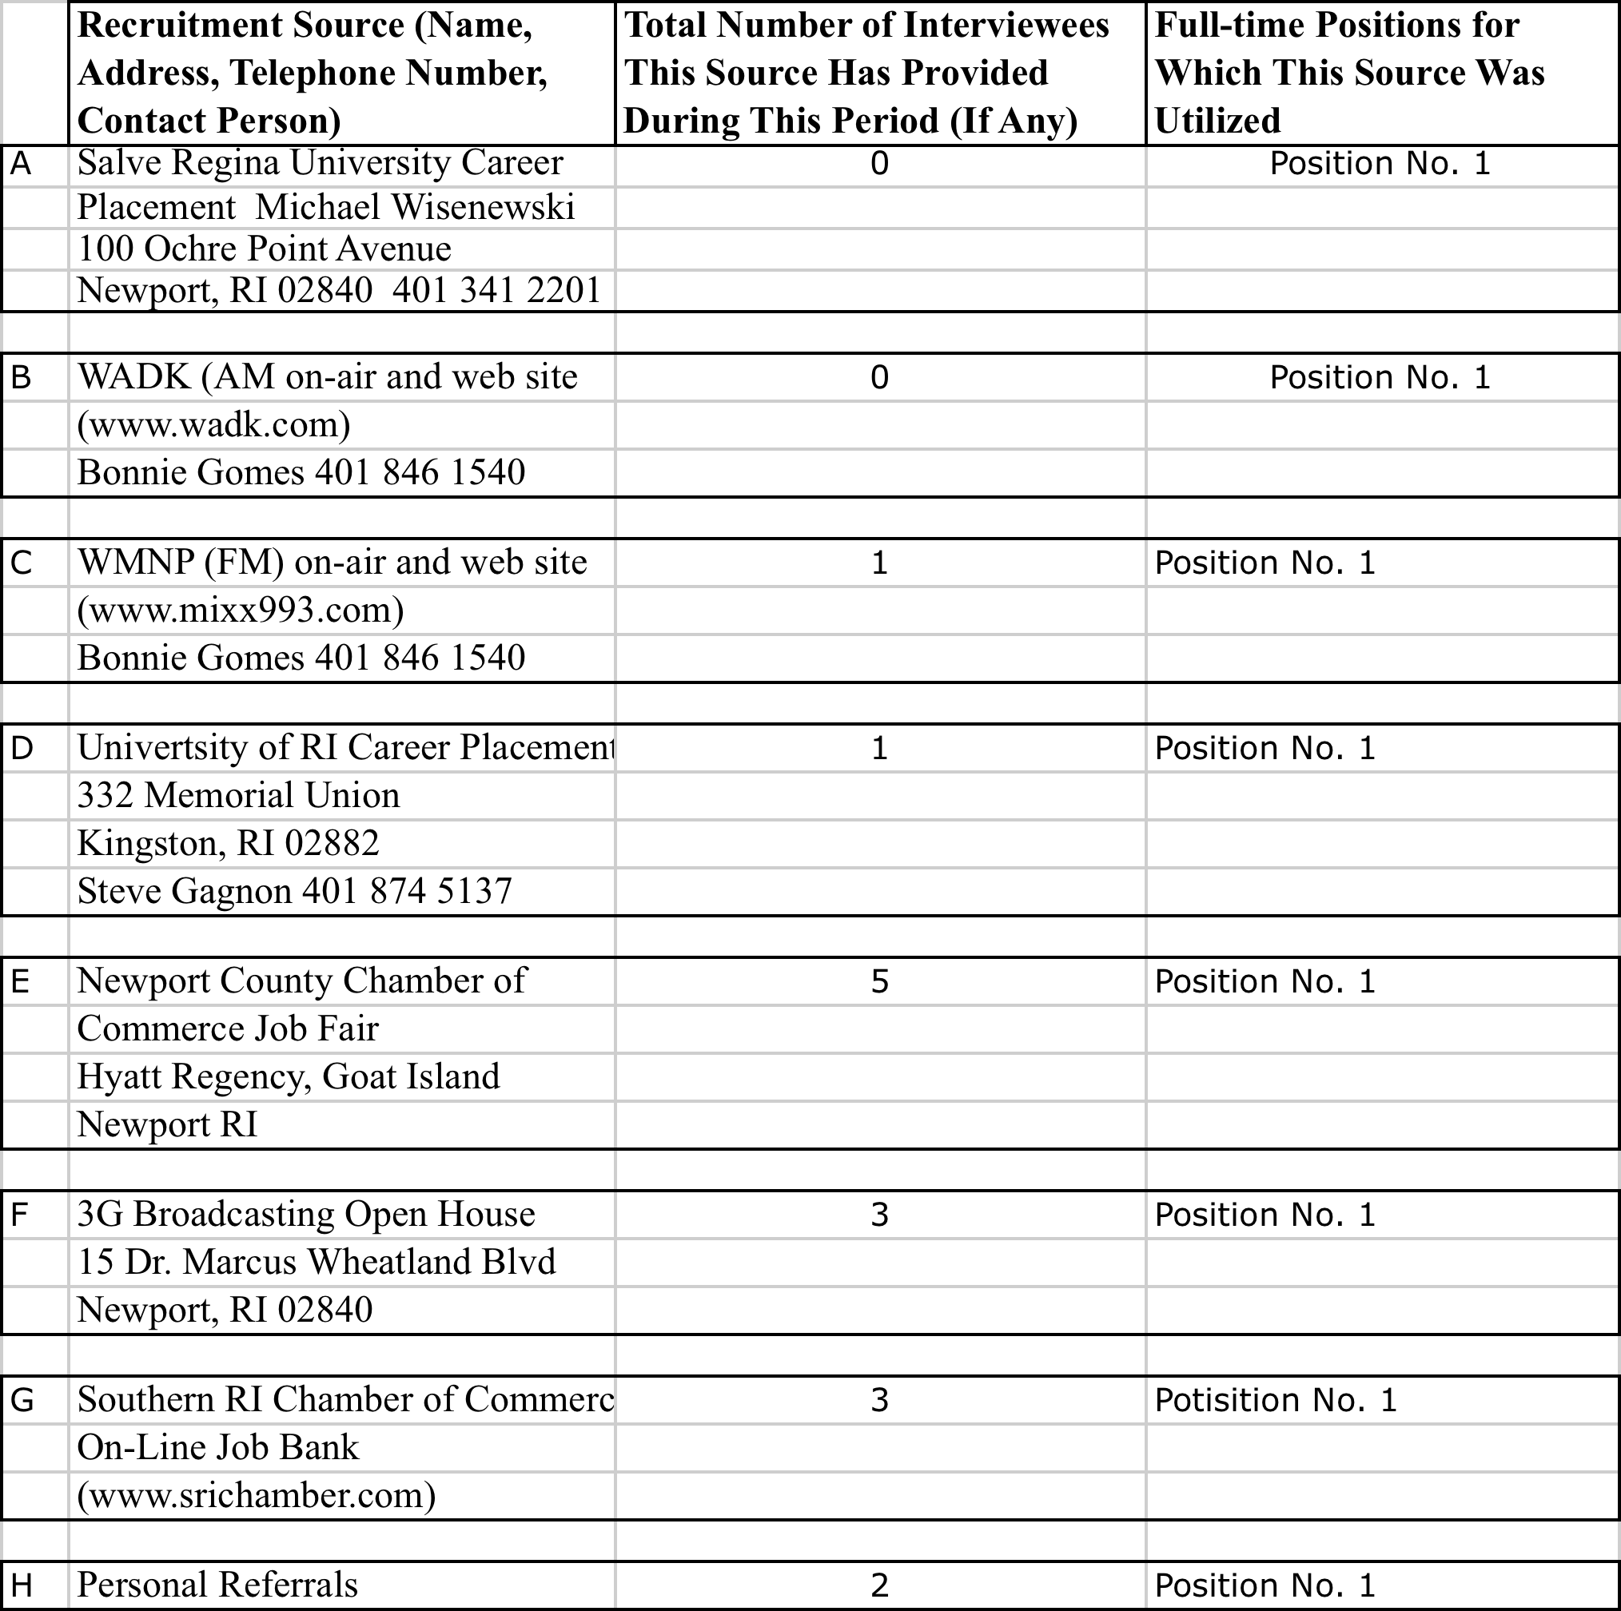

Appendix 3 to
Annual EEO Public File Report
Covering the Period from December 1, 2014 to November 30, 2015
Station(s) Comprising Station Employment Unit: WADK (AM)/WMNP (FM)

Section 3: Supplemental (Non-Vacancy Specific) Recruitment Activities Undertaken by WADK (AM)/WMNP (FM)

The stations have established a program to encourage and foster local people an opportunity to acquire real world experience and job skills in the area of broadcasting.

- WMNP-FM and WADK-AM has a training program to expose current employees to other careers in broadcasting. Our part-time talk newscaster and our producer are being exposed to other duties including, but not limited to, promotions, production, web site, etc. They are being trained by the operations manger and the head of programming.

- During this reporting period, we hosted interns from the University of Rhode Island. The internships were in exchange for college credits. The interns helped with promotions and marketing.

- WMNP-FM and WADK-AM participated in the Newport County Chamber of Commerce Job Fair. The event was held March 10, 2015 at the Hyatt Regency, Goat Island, Newport from 4pm-7pm. Applications and resumes for the Account Executive position were accepted on site.

